Name: Soumyadip Ghosh
Registration No.: 23BCB0067
Course: Web Programming (BCSE203E)
Topic: Visual SQL Builder
Review 2 : Module/Functions Design and Implementation document

1. Introduction
The Visual SQL Query Builder is a client-side web application developed using HTML, CSS, and JavaScript. The application enables users to visually construct SQL queries without manually writing SQL syntax.
The system provides an intuitive interface where users can:
- Select database tables
- Choose columns to retrieve
- Apply filtering conditions
- Sort query results
- Limit returned records
Since the system operates entirely on the client side, database operations are simulated using mock datasets stored in JavaScript modules. The application follows a modular architecture and Model–View–Controller (MVC) design pattern to ensure maintainability and scalability.

2. Module Architecture Diagram
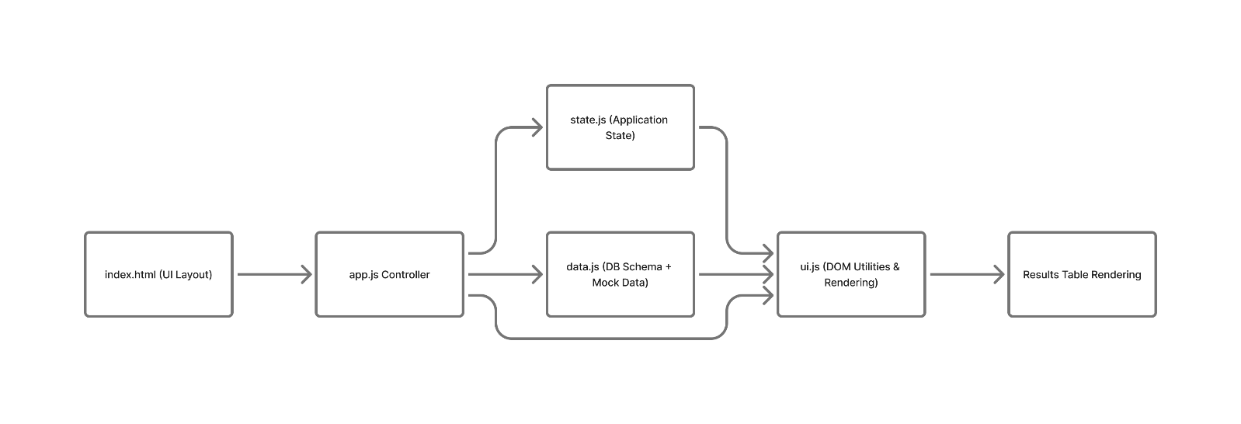
The system is divided into multiple modules, each responsible for a specific functionality. This modular structure improves code organization, reusability, and maintainability.
The main modules of the system are:
2.1 HTML Interface (index.html)
This file defines the structure of the application interface. It includes components such as:
- Query builder panel
- Table selection dropdown
- Column selection checkboxes
- Filter inputs
- Results display table
It serves as the entry point of the application.
2.2 Controller Module (app.js)
The controller module manages the interaction between the user interface and application data.
Responsibilities include:
- Listening to user events
- Updating application state
- Generating SQL queries
- Triggering result rendering
It acts as the central coordinator of the system.
2.3 State Management Module (state.js)
This module stores the current state of the query being constructed.
The state includes:
- Selected table
- Selected columns
- Filter conditions
- Sorting options
- Result limit
Maintaining a centralized state allows the application to track user input consistently across different components.
2.4 Data Module (data.js)
The data module simulates a database environment.
It contains:
- Database schema definitions
- Mock datasets representing table records
This module allows the system to simulate SQL query execution without requiring a real database connection.
2.5 UI Rendering Module (ui.js)
The UI module handles DOM manipulation and dynamic interface updates.
Functions in this module perform tasks such as:
- Accessing HTML elements
- Populating dropdown menus
- Rendering query results
- Updating the results table dynamically
This module ensures the interface updates correctly based on user actions.

3. Application Flow Diagram
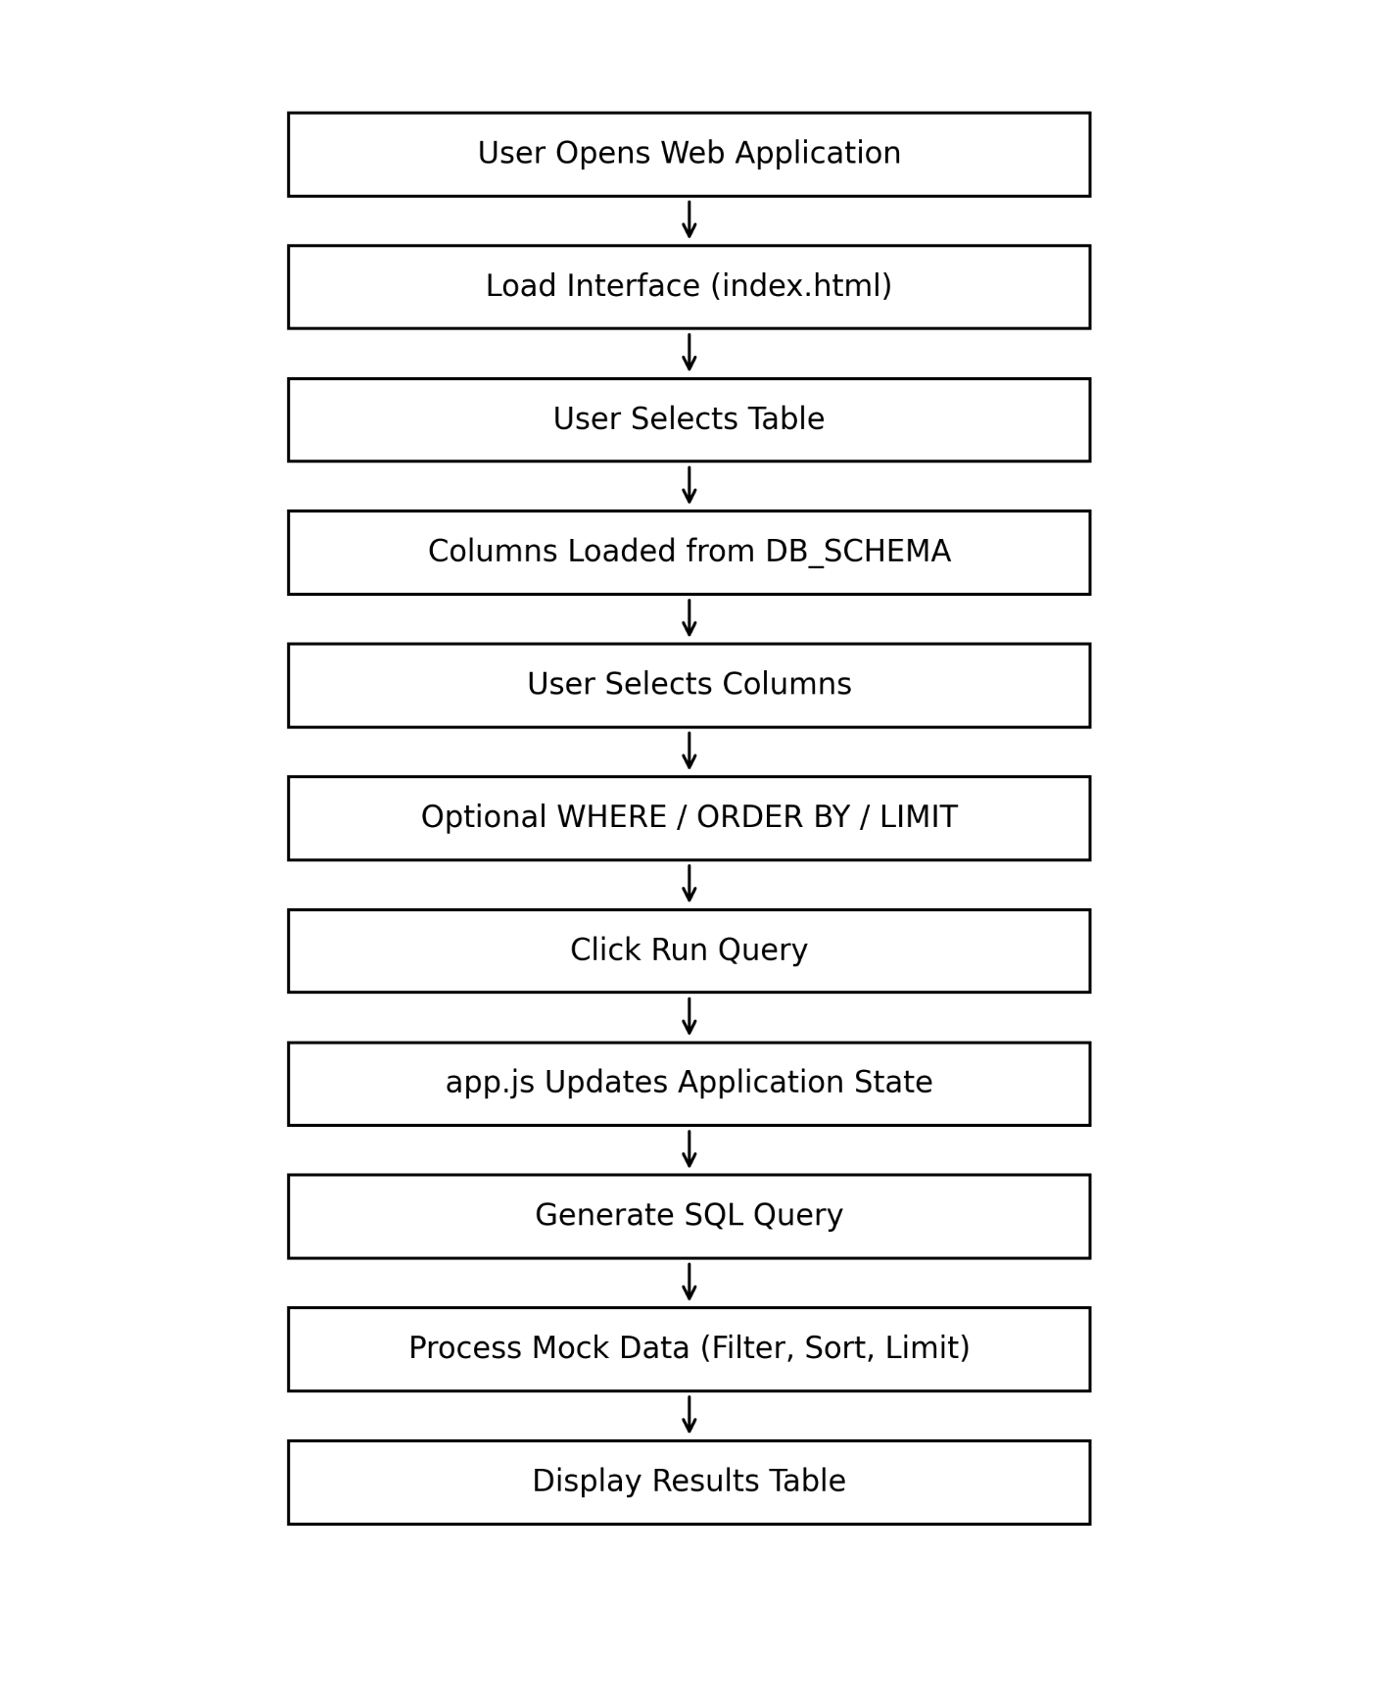
The Application Flow Diagram illustrates how data flows through the system when a user builds and executes a SQL query.
Step 1: Application Initialization
When the user opens the website, the HTML interface loads and the JavaScript controller initializes event listeners.

Step 2: Table Selection
The user selects a table from the FROM dropdown menu.
The application then:
- Retrieves the schema of the selected table
- Dynamically generates column selection checkboxes
- Updates filter and sorting dropdown menus
Step 3: Column Selection
The user selects one or more columns to retrieve. These selections form the SELECT clause of the SQL query.
The selected columns are stored in the application state.
Step 4: Query Configuration
The user may optionally specify:
- WHERE clause to filter records
- ORDER BY clause to sort results
- LIMIT clause to restrict number of rows
These parameters are stored in the state object.
Step 5: Query Execution
When the Run Query button is pressed, the application:
- Validates user input
- Constructs a SQL query string
- Updates the results display
Step 6: Query Processing
The system processes the query using JavaScript array operations:
- Filtering records
- Sorting results
- Limiting the dataset
This simulates the behavior of an actual SQL database.
Step 7: Results Display
The processed data is rendered dynamically in the results table. The generated SQL query is also displayed for reference.

4. MVC Architecture Diagram
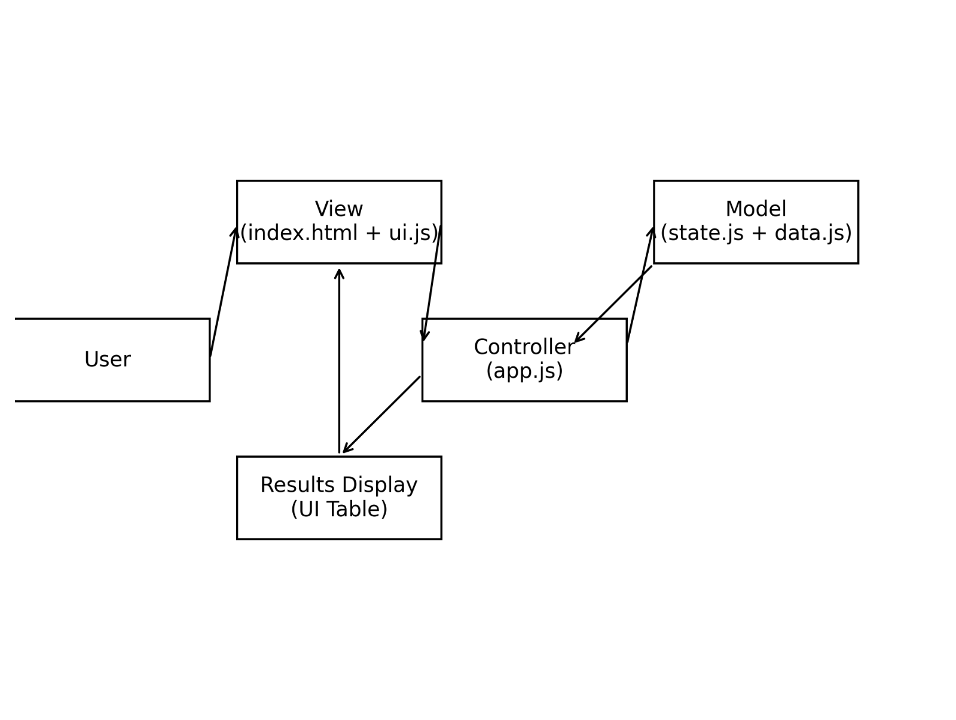
The application follows the Model–View–Controller (MVC) architectural pattern to separate concerns and improve maintainability.
4.1 Model
The Model manages the data and application state.
Components:
- data.js
- state.js
Responsibilities:
- Store database schema
- Maintain mock data
- Manage current query state
The model represents the logical data layer of the application.
4.2 View
The View represents the user interface.
Components:
- index.html
- ui.js
Responsibilities:
- Display query builder interface
- Render query results
- Update UI elements dynamically
The view ensures that user interactions are visually reflected on the interface.
4.3 Controller
The Controller connects the Model and View.
Component:
- app.js
Responsibilities:
- Handle user interactions
- Update application state
- Trigger UI updates
- Coordinate query execution
The controller ensures smooth communication between the data layer and the user interface.

